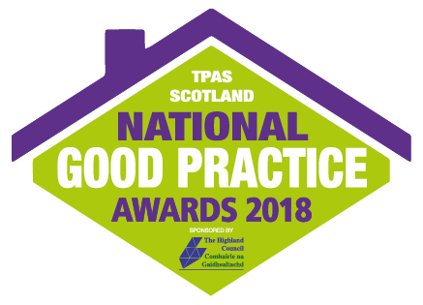
Best Practice in Achieving Service Change by Tenant Led Scrutiny
This award recognises what landlords and tenants have achieved to improve services through scrutiny of the Scottish Social Housing Charter’s outcomes. Arising from scrutiny activities we want to see evidence of:

- better service performance results and / or
- higher customer satisfaction and / or
- reduced costs of service delivery

In this award the judges are looking for excellent examples of the impact scrutiny has made to services and how this has translate to identifiable benefits for customers, levels of satisfaction and landlord’s performance. The judges want to be inspired by the proven benefits of scrutiny.

This award will recognise those truly tenant led scrutiny opportunities that provide excellent improvement or change to services.

Nominee:

Your name:

Your organisation:

Your contact details:
Phone Number:

Email address:

Which service(s) has been scrutinised

How has the service(s) improved for users?

How has satisfaction with this service changed as a result of scrutiny recommendation(s)?

How has the costs of the service(s) been effected as a result of the changes recommended through the scrutiny activity?

Entries can be submitted by email to elaine.scoular@tpasscotland.org.uk. More evidence, newspaper clippings, photographs or video can be submitted by sending a disc/pen drive to TPAS Scotland.
Please note that all applications should be submitted no later than Friday 31st August 2018. Submissions received after this date unfortunately cannot be included. Finalists will be notified by 21st September 2018
Frequently Asked Questions
Please see below some pointers and guidelines on entering and attending the awards:
Q. Is there a charge to enter?
A. There is no cost to enter the National Good Practice Awards 2018
Q. Is there a limit to the number of entries I can submit?
A. No. We will accept more than one entry from the same organisation, including (where appropriate) multiple entries into the same category, but please ensure that your entries are substantially different.
If you have a project or initiative that you think could be applied to more than one category, please determine which category you feel is most appropriate for it. Please do not enter the same project into two different categories.
Q. Can I enter by post?
A. Yes. You can enter by completing our submission form or in a Word format with the questions and criteria from the application submission. Alternatively and preferred would be email submissions
Q. Can I enter jointly with a partner organisation?
A. Yes. For the categories that recognise a particular project or initiative, we would welcome joint entries from organisations that have worked together.
Q. Can I resubmit a project that has been considered in previous years?
A. Projects that have already been considered by the judges in previous years should only be resubmitted if there has since been a significant change or advancement in the project.
Q. Can I provide further evidence, in addition to completing the entry form, to support my entry?
A. Yes you can submit up to 5 pictures and one newsletter via email to elaine.scoular@tpasscotland.org.uk
Q. When will I hear if my entry has been successful?
A. The closing date for submissions in all categories is Friday 31st August 2018. Due to the number of submissions that are received we are unable to accept entries after this date. The judging panel will meet soon after this date and you will be notified if your entry has been shortlisted. The eventual winners are then chosen by an independent panel made up of leading figures from throughout the housing sector.
Q. Will I get feedback on my entry?
A. Yes this will be provided upon request
Q. What makes a good entry?
A. Try to bear the following tips in mind when completing the online entry form:
- Make sure that you have answered all the questions as fully as possible
- Keep your entry concise and focused
- Do not exceed the maximum word count
  - The judges will be looking for tangible evidence to support your entry. Please supply performance data, costs, testimonials or user feedback where possible
- Only submit supporting evidence if it helps to support your success.
Q. What happens if we are shortlisted?
A. You will be invited to attend the Awards ceremony and Gala Dinner hosted by Jane McCarry and Mark Cox, at the TPAS Scotland National Annual Conference on Friday 16th November at the MacDonald Aviemore Resort. The awards are not just about rewarding excellence, they are also about showcasing successful or innovative ways of working and helping others to learn from and replicate your achievements. Q. Who can I contact if I have any other questions or have difficulty completing the entry form?
Please contact Elaine Scoular: elaine.scoular@tpasscotland.org.uk 0141 552 3633

