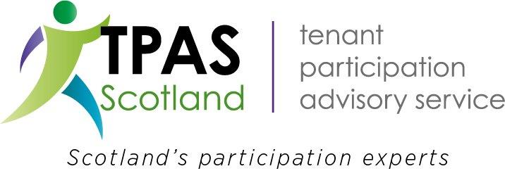
National Good Practice Awards 2019

Best Practice in Developing Communities Award

In this category we’re looking for examples of various ways that communities can be developed.

This award can include submissions that have focused on and achieved success in developing:

- Community activities and facilities
- Employment, cultural, artistic or social opportunities
- Skills and confidence of community members
- Housing options
- Housing conditions
- The environment, locally or on a wider scale, including recycling, thermal efficiency, fuel poverty, etc.
- Local pride and community spirit
- Opportunities to reduced barriers between individuals and groups
- Physical, mental and emotional health and wellbeing.

The judges are looking or examples of teams (including any mix of tenants, other service users, staff, board members, contractors, businesses and agencies) who have by working together improved or built opportunities in their community.

Nominee:

Your Name:

Your Organisation:

Your contact details: email:

Telephone:

1: What is the nominee’s aims/objectives for this activity / project?

2: How does the nominee engage, involve and empower tenants and residents?

3: What differences has the nominee achieved?

4: How has the nominee dealt with issues of equality and diversity?

5: Has the nominee achieved its aims/objectives?

Entries can be submitted by email to elaine.scoular@tpasscotland.org.uk. More evidence, newspaper clippings, photographs or video can be submitted by sending a disc/pen drive to TPAS Scotland.
Please note that all applications should be submitted no later than Friday 4th October 2019. Submissions received after this date unfortunately cannot be included. Finalists will be notified by 18th October 2019
Frequently Asked Questions
Please see below some pointers and guidelines on entering and attending the awards:
Q. Is there a charge to enter?
A. There is no cost to enter the National Good Practice Awards 2019.
Q. Is membership of TPAS Scotland required
A. No, anyone, any organisation can apply
Q. Is there a limit to the number of entries I can submit?
A. No. We will accept more than one entry from the same organisation, including (where appropriate) multiple entries into the same category, but please ensure that your entries are substantially different.
If you have a project or initiative that you think could be applied to more than one category, please determine which category you feel is most appropriate for it. Please do not enter the same project into two different categories, the judges will decide if your submission should be considered in a different category
Q. Can I enter by post?
A. Yes. You can enter by completing our submission form or in a Word format with the questions and criteria from the application submission. Alternatively, and preferable would be email submissions. Please email these to: elaine.scoular@tpasscotland.org.uk
Q. Can I enter jointly with a partner organisation?
A. Yes. For the categories that recognise a particular project or initiative, we would welcome joint entries from organisations that have worked together.
Q. Can I resubmit a project that has been considered in previous years?
A. Projects that have already been considered by the judges in previous years should only be resubmitted if there has since been a significant change or advancement in the project.
Q. Can I provide further evidence, in addition to completing the entry form, to support my entry?
A. Yes, you can submit up to 5 pictures and one newsletter via email to elaine.scoular@tpasscotland.org.uk
Q. When will I hear if my entry has been successful?
A. The closing date for submissions in all categories is Friday 4th October 2019. Due to the number of submissions that are received we are unable to accept entries after this date. The judging panel will meet soon after this date and you will be notified if your entry has been shortlisted. The eventual winners are then chosen by an independent panel made up of leading figures from throughout the housing sector.
Q. Will I get feedback on my entry?
A. Yes, this will be provided upon request
Q. What makes a good entry?
A. Try to bear the following tips in mind when completing the online entry form:
- Make sure that you have answered all the questions as fully as possible
- Keep your entry concise and focused
- Do not exceed the maximum word count
  - The judges will be looking for tangible evidence to support your entry. Please supply performance data, costs, testimonials or user feedback where possible
- Only submit supporting evidence if it helps to support your success.
Q. What happens if we are shortlisted?
A. You will be invited to attend the Awards ceremony and Gala Dinner, at the TPAS Scotland National Annual Conference on Wednesday 4th December 2019 at the Fairmont Hotel in St Andrews. The awards are not just about rewarding excellence, they are also about showcasing successful or innovative ways of working and helping others to learn from and replicate your achievements.
Q. Who can I contact if I have any other questions or have difficulty completing the entry form?
A: Please contact Elaine Scoular: elaine.scoular@tpasscotland.org.uk 0141 552 3633

